TITLE: SAMPLE FOR “ZADANIE 3” – DEGREE OF DIFFICULTY 41–65%

Jan Nowak

AGH University of Krakow, Faculty of Geology, Geophysics and Environmental Protection; al. A. Mickiewicza 30, 30-059 Krakow, Poland, e-mail: jan.nowak@interia.pl; ORCID ID: 0000-0002-9079-593Y

© 2024 Author(s). This is an open access publication, which can be used, distributed and reproduced in any medium according to the Creative Commons CC-BY 4.0 License requiring that the original work has been properly cited.

Received: 1 January 2024; accepted: 15 February 2024; first published online: 1 March 2024

Abstract: The paper presents the variability of methane emissions in mining excavations in the Brzeszcze mine (Poland) against the background of hard coal output, geological and mining factors. The geological structure of the Upper Silesian Coal Basin (USCB) is very diverse. The Brzeszcze coal deposit is located close to the large and permeable Jawiszowice fault which increases the methane hazard during mining activities performed close to this fault. The overall decrease in hard coal output (1988–2018) has coincided with a rapid increase in methane emissions (1997–2018). Throughout the study period, hard coal output decreased threefold from 3.9 to 1.2 million Mg annually. Coal extraction in high methane content beds (e.g., 510, 405/1, 364, 352) increases the total methane (CH₄) emission into mining excavations, aggravating the methane hazard due to the high explosiveness of the gas. To protect miners, coal workings need to be continuously ventilated, taking the harmful gas out of the mine (ventilation air methane emission) or methane needs to be captured by underground methane systems (degassing).

Keywords: methane emission, the Upper Silesia Coal Basin, hard coal production, ventilation air methane, the Brzeszcze mine

INTRODUCTION
The Brzeszcze mine is located in the Upper Silesian Coal Basin (Poland) in the Małopolska and Silesia voivodeships (provinces) (Fig. 1). The Upper Silesian Coal Basin (USCB) is the largest coal basin in Poland, and one of the largest in Europe. It covers an area of 5600 km² in Poland and 1900 km² in the Czech Republic (Kędzior 2009).
The USCB sedimentary basin was formed during the Variscan orogeny. At the end of the Permian period, the denudation and weathering processes of uplifted Paleozoic strata began. In the Miocene period, marine transgression took place in the USCB area. The Upper Carboniferous strata was developed in an area with lush plants and trees after the sea retreated. Thick and continuous loam layers were deposited directly onto the Carboniferous strata, preventing methane and other gases from being naturally released directly into the atmosphere. The thickness of the Carboniferous strata exceeds 6000 m (Bałuk & Wyrwicki 1972, Kotas 1990).
Hard coal production is one of the most strategic branches in the economy and power production in Poland. Almost 50% of the energy produced comes from hard coal power plants. Poland is the biggest hard coal producer in Europe, but Germany is the biggest hard coal consumer for power production (93 TWh produced from coal). Poland, with 79 TWh, is in second place (Euracoal 2019). Coal from USCB is derived from increasingly deeper beds every year, a trait characteristic of underground coal mining. In 2000, the average depth of extraction was 600 m, ten years later it was 700 m, and the depth is increasing by 8–10 m every year. In the last year of studies (2018), the average depth was 788 meters (Report 1995–2018, Szlązak et al. 2013).

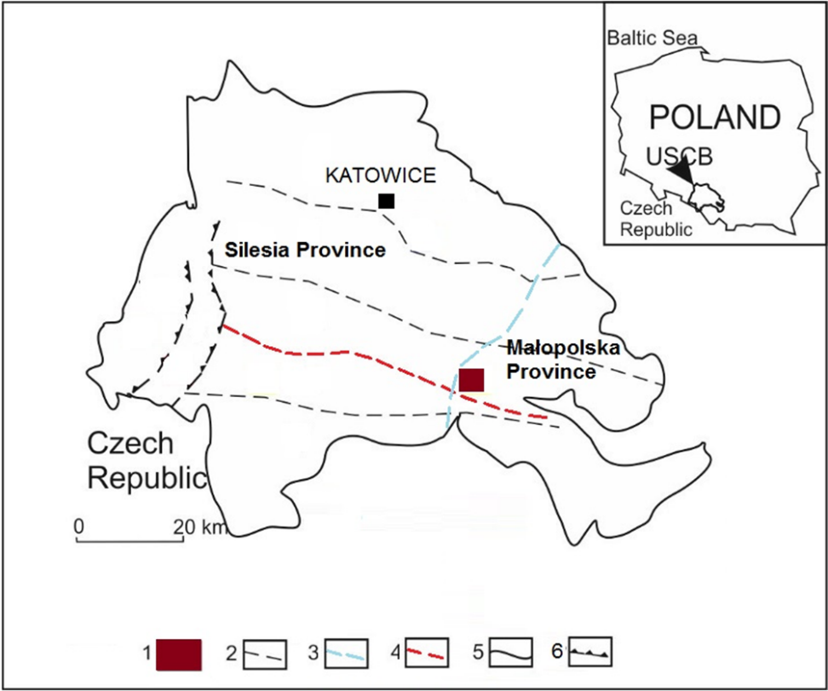
Fig. 1. The Brzeszcze coal mine location: 1 – Brzeszcze mine, 2 – faults, 3 – Silesia and Małopolska boundary line, 4 – the Jawiszowice fault, 5 – the USCB boundary, 6 – overthrusts

The purpose of this paper is to show the causes and effects of changes in methane emissions in the Brzeszcze mine. These changes are shown against the background of coal production, geological and mining factors. The studies of methane release changes were made for the 1997–2018 time period, during which coal production entered coal seams with higher methane content and when a constant decline in hard coal output was observed. As a result, the Brzeszcze mine has been struggling with one of the highest methane emissions in the entire Upper Silesian Coal Basin.

METHODOLOGY
The paper presents the variabilities of absolute methane emissions, ventilation air methane emissions, outgassing (1997–2018) and hard coal production (1988–2018) in the Brzeszcze mine in the south-eastern part of the USCB. The description of methane emissions and hard coal production was taken from official geological documentation/internal reports prepared specifically for the Tauron Wydobycie – Brzeszcze mine (Tauron – internal report).
The data comprise:
- geological structure of coal deposits,
- stratigraphy,
- lithology,
- tectonics,
- methane emissions,
- methane content,
- overall hard coal output.
Supplementary data were used from Annual Report (for the years 1994–2018) on the state of basic natural and technical hazards in the hard coal mining industry (Report 1995–2018) published annually by the Central Mining Institute (Główny Instytut Górnictwa) in Katowice and The Accident Statistics (State Mining Authority 2019) published by the State Mining Authority (Wyższy Urząd Górniczy) in Katowice.
The balance of the absolute methane emission of the coal mine Q_{me} is based on the sum of ventilation air emission (Q_{v}) and outgassing (Q_{o}):
Q_{me} = Q_{v} + Q_{o},
where:
Q_{me} – the absolute/total methane emission [m³/min],
Q_{v} – the ventilation air methane (VAM) emission [m³/min],
Q_{o} – the outgassing/methane drainage [m³/min].
The VAM emission Q_{v} contains the average volume of methane which was released into the ventilation air flowing in mine workings, diluted with mining air and taken out of the mine by underground ventilation shafts. The volume of CH₄ in the air flow is measured by methane sensors. The outgassing Q_{o} refers to the average volume of captured methane from the underground methane drainage network, measured by gas/methane detectors in the methane drainage pipelines released from the ventilation area (Koptoń & Wierzbiński 2014).
The specific methane emission (Q_{sp}) refers to volume of emitted methane with every single extracted Mg of coal, and is given as m³/Mg:
Q_{sp} = Q_{me}/P_{c},
where:
Q_{sp} – specific methane emission [m³/Mg],
Q_{me} – the absolute/total methane emission [m³/min],
P_{c} – the hard coal output [Mg/day].

STRATIGRAPHY, LITHOLOGY AND TECTONICS
The geological structure of the Brzeszcze coal deposit consists of Quaternary, Neogene (overburden) and Carboniferous (coal bearing strata) deposits. Coal beds are found at 40 to 1,150 m below ground level and coal seam thickness is variable.

Carboniferous
The Upper Silesian Sandstones Series (USSS) was deposited discordantly upon the Paralic Series and it is the first lithostratigraphic unit of the continental Carboniferous coal bearing strata in the USCB (Jureczka & Kotas 1995). The coal bearing strata has been prospected to 1,150 m below ground level, where the bottom of the 510 coal seam occurs. There are 31 documented coal seams in the Brzeszcze coal deposit.
For the coal deposits in the Brzeszcze mine, the Doktorowicz-Hrebnicki & Bocheński division was applied (Doktorowicz-Hrebnicki & Bocheński 1952):
- Westphalian C – Łaziska layers (coal seams group 200),
- Westphalian B – Orzesze layers (coal seams group 300),
- Westphalian A – Ruda layers (coal seams group 400),
- Namurian B-C – Saddle layers (coal seams group 500),
- Namurian A – Poruba layers (coal seams group 600).
Poruba layers consist of siltstones and mudstones interbedded by fine-grained sandstones and a few thin coal seams. The thickness of the Poruba layers has not yet been established, but the highest thickness found by deep drillings is 275 m. The most important prospected coal seam, 610, is not currently exploited.
Saddle layers are the thinnest complex documented in the Brzeszcze coal deposit. The thickness varies from a few to 20 m. Layers developed as concise fine and medium grained sandstone, with the currently exploited coal seam 510. The bottom of the 510 coal seam forms the bottom of the Saddle layers.
Ruda layers are represented by a siltstone-sandstone complex with a thickness of 120 m. Middle and fine-grained sandstones were deposited in lower parts of the complex, beneath the 407 coal seam. There are six documented seams – 401 is now operated, 405/1, 405/2 and 407 were exploited in the past, but 404 and 416 have never been used for coal extraction.
Orzesze layers are found over the entire Brzeszcze coal deposit with their thickness increasing from the east (375 m) to the west (545 m), with average thickness of 500 m in the central part of the deposit. The Orzesze layers were developed as siltstones, mudstones and sandstones with numerous coal seams. There are 19 documented coal seams, with 15 operating in the past, but now only coal bed 352 is being exploited.
Łaziska layers are built mainly of fine, medium and coarse-grained sandstones, with minor occurrences of siltstones. The thickness of these layers is very diverse, but the largest thickness – over 275 m – was found in the northern part of the deposit. Of coal seams of the 200 group, only coal seam 215 was mined.

Neogene (Miocene)
Neogene (Miocene) deposits are represented by loams, shale loams with sand inserts. The thickness of Miocene formation is strictly dependent on the shape of the eroded Carboniferous top surface. In Carboniferous elevated parts, Miocene deposits have the lowest thickness (16 m), whereas in the rest of the area, Miocene thickness is higher – 188m in the north and up to 252 m in the southern part of the area.

Quaternary
Quaternary deposits cover the entire study area, with thicknesses varying from 6.5 to 39.0 m. Most of the deposits occur as clays, sands and gravels. The Brzeszcze mine area is located in the fault zone within the Main Syncline, which is an extended synclinal structure running in a NW-SE direction and cut by numerous faults. The Brzeszcze coal deposit is located in the up-throw of the Jawiszowice fault zone, where coal seams to the depth of 300–500 m below the ground surface were naturally degassed (Fig. 2).

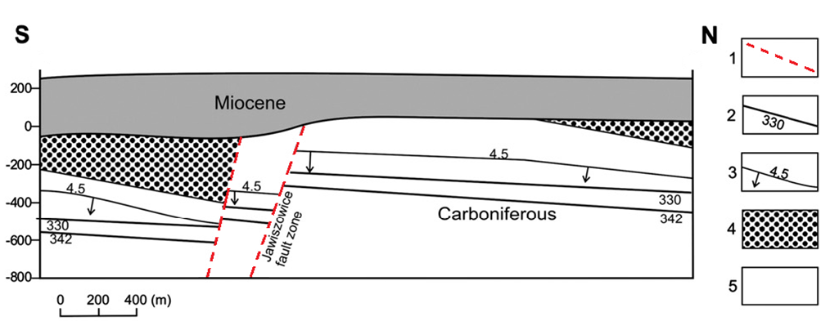

Fig. 2. Schematic cross sections with variations of methane content in Brzeszcze coal mine (Kędzior et al. 2013): 1 – fault zones, 2 – coal seam with identification number, 3 – line of methane content with arrow indicating the direction of increasing values, 4 – Cracow Sandstone Series, 5 – remaining series of the USCB Carboniferous system

Fault tectonics is a very important factor in the entire USCB, influencing the distribution of methane concentrations. The thirteen main dislocations (faults) were found in the area of the Brzeszcze coal deposit. The most important faults are presented in Table 1. The regional, large-size dislocations such as Jawiszowice (Brzeszcze mine), Bzie-Czechowice (Silesia mine) or Książ (Mysłowice-Wesoła mine) fault zones drop the coal seams with high methane content according to the throw direction – southwards (Kędzior et al. 2013). The regional dislocations in the USCB are Variscan structures that are still active (Teper & Sagan 1995).

Table 1. Main fault characteristics (Tauron – internal report)
Longitudinal direction | Throw size / drop direction / dip
I western fault | SSW–NNE / 0–15 m / 60–70°
I eastern fault | SSW–NNE / 1–15 m / 65–70°
II eastern fault | SSW–NNE / 25–90 m / 45°
III eastern fault | SW–NE / 3–90 m / 50°
IV eastern fault | SW–NE / 0–30 m / 50°
Fault close to seam 327 | N–S / 0–20 m / 65°

The width of the Jawiszowice fault zone is (the southern boundary of the deposit) very large – 400 m. It consists of three smaller faults with a total throw of over 1,100 m. In addition to the 13 main faults, there are many numerous smaller dislocations with throws between 0.5–11 m (Tauron – internal report, Tauron Brzeszcze mine website, Kędzior et al. 2013).

RESULTS AND DISCUSSION
Hard coal output
In the Brzeszcze mine, hard coal is extracted under very unfavourable methane conditions, mostly classified as IV category of methane hazard (Regulation of the Ministry of the Environment 2013) where CH₄ can be released very easily during mining activities. In the past, the coal was extracted from methane-free, naturally degassed depths – 170, 230, 260 and 360 m in the northern part of the deposit. Historical sources state that in 1964 the first large methane emission to coal excavations was reported – 23.23 million m³ in a year due to mining activities started at the depth of 430 m below ground level (Tauron – internal report). The vertical distribution of methane accumulation (the average values) shows that highly methane bearing seams (>4.5 m³/Mg coal^{daf}) occur at the approx. 450 m BGL and deeper (Fig. 3).

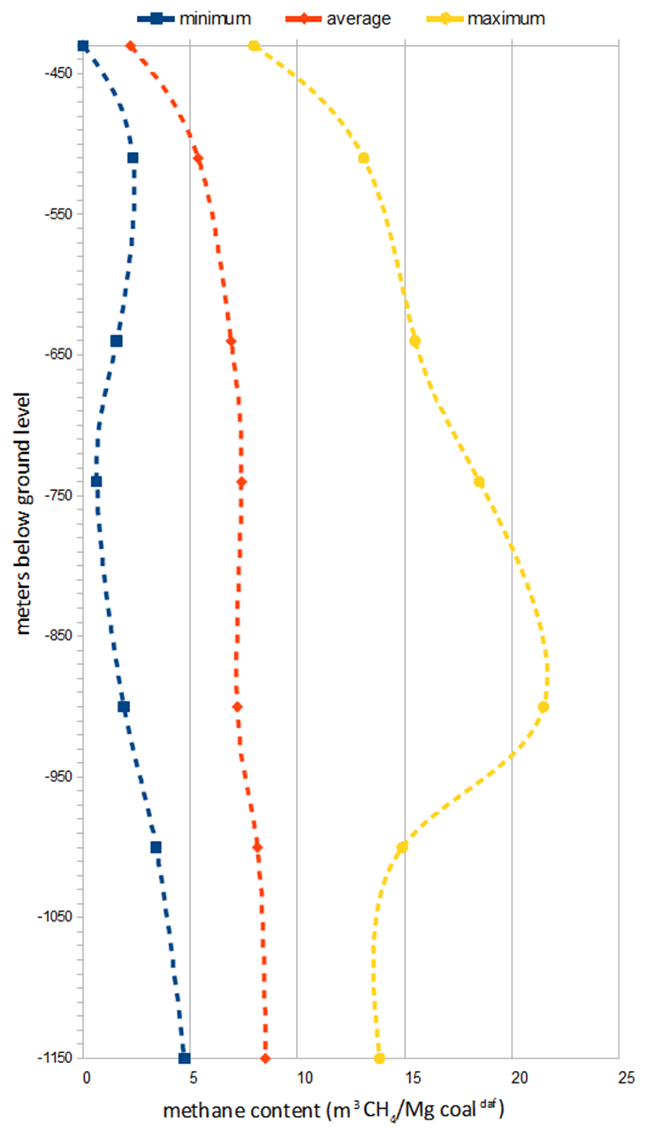
Fig. 3. Simplified vertical distribution of the methane content in the Brzeszcze mine (Tauron – internal report)

Absolute methane emissions
These studies cover the 1997–2018 time period, when the Brzeszcze mine changed the model and structure of its coal production. Since 1997, the Brzeszcze coal mine has been working as an individual enterprise. In previous years, the Brzeszcze mine was combined with the Ruch II Jawiszowice, but after coal resources depleted (to 512 production level), Ruch Jawiszowice II was closed. In the late 1990’s, the Brzeszcze coal mine decreased the number of operating walls – from 14 to 2, extending its length to 250 m and the wall run to 400–1400 m at the same time (Tauron – internal report). These changes improved the coal output from one wall, but the total hard coal production decreased every year. The methane emission variations have changed twofold. Methane emissions into coal excavations increased due to output concentration from one longwall – longer walls and faster mining activities (underground preparations, roadheaders works and coal exploitation) favours the release of CH₄ from relaxed coal and surrounding rocks to the operating coal workings (Krause & Łukowicz 1999, Turek 2007, Krause 2019). On the other hand, total methane emissions have decreased due to the substantial decrease in total coal production (Krause & Łukowicz 1999, Turek 2007, Tauron – internal report). In the period studied (1997–2018), the absolute methane emission did not change significantly. From 1997 to 2005 a constant but gentle decline was observed – from 124.80 to 101.04 million m³/year (Fig. 5). In the following years (2006–2009), an increase in total CH₄ emission was recorded. In 2006–107.37 million m³ of methane was released into mine excavations. Three years later, the emission increased by 13% to 121.65 million m³ of methane. In succeeding years (2010–2015), the total emission dropped again, from over 116 million m³ to 75.61 million m³ in 2015. It was the lowest, recorded volume of emitted CH₄ in the entire research period.
In recent years, coal extraction operations were carried out at a greater distance from the Jawiszowice fault, and at greater depths (in lower methane bearing seams), which caused a reduction in methane emissions (Fig. 4) (Krause & Łukowicz 1999, Tauron – internal report, Report 1997–2018).

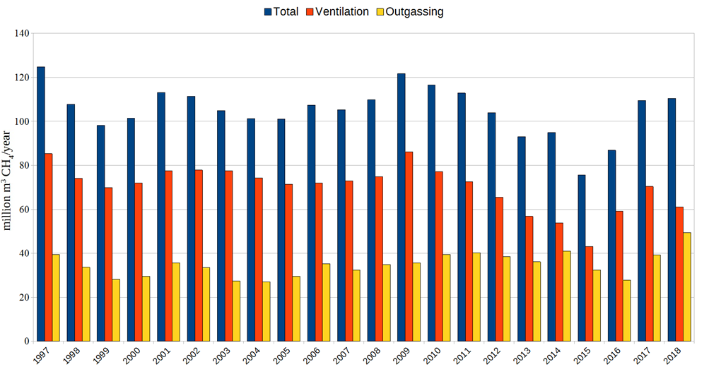
Fig. 4. The absolute methane emission (total), VAM emission and outgassing in Brzeszcze mine in 1997–2018 (Tauron – internal report)

The real methane hazard in working mines can be shown in terms of the specific methane emission. It is the total methane emission related to the overall hard coal output given as m³ CH₄/Mg coal. From 1997 to 2004 the specific CH₄ emission varied from 42 to 50 m³ CH₄/Mg coal.

SUMMARY
The Brzeszcze mine produces hard coal for power production from the Brzeszcze coal deposit located in the Upper Silesian Coal Basin in Poland. The upper coal seams, which were depleted in the past, were free of methane or the CH₄ content was too low to pose any real danger. Now, the Brzeszcze coal mine is characterised by one of the highest methane emissions into coal workings in the entire USCB. The most important natural factors forming methane content and emission are the lithology of the Carboniferous coal bearing strata (the upper parts of the deposit were naturally degassed due to the highly porous Łaziska sandstones) and fault zone occurrence (Jawiszowice). The methane distribution in the coal deposit has mainly been shaped by the Jawiszowice fault – the regional dislocation which has oriented the coal bearing strata according to the throw direction – southwards. The high permeability of the Jawiszowice fault and secondary methane accumulation in the beds are reflected in higher methane concentrations in seams close to the dislocation. Mining activities, such as preparatory works or coal extraction, carried out in the seams located close to the Jawiszowice fault, are burdened by high methane emissions into the mining excavations from coal, surrounding rocks, and the underlying and overlying strata. Further from the fault, the CH₄ content decreases. Mining works located further from the Jawiszowice fault and on greater depths, where CH₄ content is lower (deeper than 740 m below ground level) are characterised by lower methane emissions into mining excavations.

This study was undertaken in the framework of the activities of the University of Silesia in Katowice and was funded by the University of Silesia, Institute of Earth Sciences (WNP/INOZ/2020_ZB32). The author is grateful to the employees of Central Mining Institute in Katowice and the employees of Tauron Wydobycie – Brzeszcze mine.

REFERENCES
Bałuk W. & Wyrwicki R., 1972. Geologia. Wydawnictwa Geologiczne, Warszawa.
Chunshan Z., Bingyou J., Sheng X., Zhongwei C. & He L., 2019. Coalbed methane emissions and drainage methods in underground mining for mining safety and environmental benefits: A review. Process Safety and Environmental Protection, 127, 103–124. https://doi.org/10.1016/j.psep.2019.05.010.
Cybulski K. & Myszor H., 1974. Próba określenia ogólnej zależności wydzielania metanu od wielkości wydobycia. Archiwum Górnictwa, 27, 2.
Doktorowicz-Hrebicki S. & Bocheński T., 1952. Podstawy i niektóre wyniki pararelizacji pokładów węgla w Zagłębiu Górnośląskim. Geologiczny Biuletyn Informacyjny, 1, 13–14.
Duda A. & Krzemień A., 2018. Forecast of methane emission from closed undergroundcoal mines exploited by longwall mining – a case study of Anna coal mine. Journal of Sustainable Mining, 17, 184–194. https://doi.org/10.1016/j.jsm.2018.06.004.
Frączek R. & Frączek J., 2004. Obliczenie wydajności emisji metanu z otworów odmetanowania górotworu w ścianach kopalń węgla kamiennego. Przegląd Górniczy, 60(11), 54–62.
Ghosh A., Patra P.K., Ishijima K., Umezawa T., Ito A. et al., 2015. Variations in global methane sources and sinks during 1910–2010. Atmospheric Chemistry and Physics, 15(5), 2595–2612. https://doi.org/10.5194/acp-15-2595-2015.
Ju Y., Sun Y., Sa Z., Pan J., Wang J., Hou Q., Li Q., Yan Z. & Liu J., 2016. A new approach to estimate fugitive methane from coal mining in China. Science of the Total Environment, 543(Pt A), 514–523. https://doi.org/10.5194/acp-15-2595-2015.
Karacan C.Ö. & Olea R.A., 2014. Inference of strata separation and gas emission paths in longwalloverburden using continuous wavelet transform of well logs and geostatistical simulation. Journal of Applied Geophysics, 105, 147–158. https://doi.org/10.1016/j.jappgeo.2014.03.019.
Kędzior S., 2009. Accumulation of coal-bed methane in the south-west part of the Upper Silesian Coal Basin (southern Poland). International Journal of Coal Geology, 80, 20–34. https://doi.org/10.1016/j.coal.2009.08.003.
Kholod N., Evans M., Pilcher R.C., Roschanka V., Ruiz F., Cote M. & Collings R., 2020. Global methane emissions from coal mining to continue growing even with declining coal production. Journal of Cleaner Production, 256, 120489. https://doi.org/10.1016/j.jclepro.2020.120489.
Kirschke S., Bousquet P., Ciais P., Saunois M., Canadell J.G. et al., 2013. Three decades of global methane sources and sinks. Nature Geoscience, 6, 813–823. https://doi.org/10.1038/ngeo1955.
Koptoń H. & Wierzbiński K., 2014. The balance of methane and ventilation as a tool for methane hazard assessment in the areas of longwalls exploited in hard coal mines. Journal of Sustainable Mining, 13(4), 40–46. https://doi.org/10.7424/jsm140308.
Kotarba M.J., 2001. Composition and origin of gases in the Upper Silesian and Lublin coal basins, Poland. Organic Geochemistry, 32, 1, 163–180. https://doi.org/10.1016/S0146-6380(00)00134-0.
Krause E., 2005. Czynniki kształtujące wzrost zagrożenia metanowego w ścianach o wysokiej koncentracji wydobycia. Przegląd Górniczy, 61(9), 19–26.
Krause E., 2019. Zagrożenie metanowe w kopalniach węgla kamiennego. Główny Instytut Górnictwa, Katowice.
Krause E. & Karbownik M., 2019. Tests of methane desorption and emission from samples of hard coal in the context of mine closures through flooding. Journal of Sustainable Mining, 18, 127–133.
Krause E. & Łukowicz K., 1999. Zagrożenia metanowe. [in]: Dubiński J. (red.), Koncentracja wydobycia a zagrożenia górnicze, Główny Instytut Górnictwa, Katowice.
Krause E. & Pokryszka Z., 2013. Investigations on methane emission from flooded workings of closed coal mines. Journal of Sustainable Mining, 12(2), 40–45. https://doi.org/10.7424/jsm130206.
Mohtasham Seyfi M., Khademi Hamidi J., Monjezi M. & Hosseini A., 2018. Estimation of coal seams gas content for evaluating potential use of methane drainage system in Tabas coal mine. Journal of Mining & Environment, 9(3), 667–677. https://doi.org/10.22044/jme.2018.6783.1501.
Molayemat H. & Mohammad Torab F., 2017. Evaluation of coalbed methane potential in Parvadeh IV coal deposit in central Iran using a combination of MARS modeling and Kriging. Journal of Mining & Environment, 8(2), 305–319. https://doi.org/10.22044/jme.2017.874.
Noack K., 1998. Control of gas emissions in underground coal mines. International Journal of Coal Geology, 35, 57–82. https://doi.org/10.1016/S0166-5162(97)00008-6.
PGNiG News, 2019. Coal-bed methane-fueled power generation unit launched by PGNiG in Gilowice. http://en.pgnig.pl/news/-/news-list/id/coal-bed-methane-fueled-power-generation-unit-launched-by-pgnig-in-gilowice/newsGroupId/1910852 [access: 1.03.2020].
State Mining Authority, 2019. Statystyki wypadków. Wyższy Urząd Górniczy, Katowice. http://www.wug.gov.pl/bhp/statystyki_wypadkow [access: 1.06.2020].
Su S., Beath A., Guo H. & Mallett C., 2005. An assessment of mine methane mitigation and utilisation technologies. Progress in Energy and Combustion Science, 31(2), 123–170. https://doi.org/10.1016/j.pecs.2004.11.001.
Szlązak N., Obracaj D. & Swolkień J., 2020. Enhancing Safety in the Polish High-Methane Coal mines: an Overview. Mining, Metallurgy & Exploration, 37, 567–579. https://doi.org/10.1007/s42461-020-00190-0.
Tauron – internal report [geological documentation, unpublished].
Tauron Brzeszcze mine website. https://www.tauron-wydobycie.pl/spolka/zg-brzeszcze/charakterystyka-zakladu [access: 1.02.2020].
Teper L. & Sagan G., 1995. Geological history and mining seismicity in Upper Silesia (Poland). [in:] Rossmanith H.P. (ed.), Mechanics of Jointed and Faulted Rock, Balkema, Rotterdam, 939–943.

