Abstract
The rapidly developing field of quantum computing and the ongoing lack of widely available quantum computers create the need for scientists to build their simulators. However, mathematical simulation of such circuits usually ignores many aspects and problems found in real quantum systems. In this article, the authors describe a quantum bit emulator based on FPGA integrated circuits. In this case, FPGA technology provides real-time massive parallelism of the modeled physical phenomena. The modeled QUBIT is represented using a Bloch sphere. Its quantum state is set and modified only by precise pulses of an electrical signal, and with the help of similar pulses, it manifests its current state in real time. The constructed QUBIT was additionally equipped with decoherence mechanisms and with circuits that intentionally respond to internal and external noises that distort its current quantum state. This article presents and discusses how such a physically built emulator works.
Keywords: quantum, qubit, FPGA, parallel, real time

Introduction
Currently, quantum physics is increasingly entering the world of information processing. The specific features of quantum phenomena (such as superposition, tunneling, or entanglement) mean that data processing carried out on the basis of quantum bits (qubits) allow achieving useful computational results in a time that would not be possible to achieve using classical methods.
However, quantum systems are still very difficult to build and maintain, so they still may not be widely available in the near future. Therefore, the idea of building a practical model of the behavior of the basic unit of a quantum computer (qubit) seems justified. After equipping such a model with a physical control system using electrical impulses, as well as a natural susceptibility to internal and external noise and sensitivity to decoherence, we will obtain a useful tool for researching and better emulating real quantum systems. By combining several such emulators, you can create more complex quantum systems and test sample quantum computing and noise reduction algorithms on them.
Effective, fault-tolerant quantum computing requires two-or-more-qubit gates with the highest possible fidelity. The recommended infidelity in the literature is below ${10}^{-4}$. Achieving such a level of fidelity in two-qubit gates implemented in an ion trap, such as the SWAP gate and the Mølmer-Sørensen gate, even in noise-free conditions, requires analysis not only of the internal states of the ions but also of the most relevant part of the phonon space. The authors hypothesize that complex emulations of this kind can be more efficiently conducted using parallel and real-time models based on FPGA integrated circuits, which may in the future enable more effective identification of both coherent and stochastic error sources. In addition, quantum processors also rely on classical electronic controllers to manipulate and read out the state of qubits. As the performance of the quantum processor improves, imperfections in the classical controller can become the performance bottleneck for the whole quantum system. To prevent such limitations, a systematic study of the impact of classical electrical signals on qubit fidelity is needed. To have an easy way to do such a study, we need a model close enough to real quantum systems. By controlling the qubit model only with real physical signals (pulses), it is possible to more accurately reproduce the control conditions of real quantum systems. Our proposal described in this article tries to meet all these needs.
This article describes the practical implementation of just such a model, based on a programmable FPGA integrated circuit. In addition to the qubit model (QUBIT), the article also details the control and reading module (GENMET), designed to generate appropriate electrical control pulses, as well as to read electrical pulses generated by the QUBIT itself, through which it informs the environment about its current state.
The article will also describe the idea of communication with such a single QUBIT and the method used to implement its susceptibility to decoherence and to internal and externally generated noise.
Next, the results and practical tests of the built emulator using the dedicated GENMET module will be described. The user can, of course, use other generators and measurement systems instead of GENMET. Finally, a brief description of possible applications will be presented.

Related works
At the time of writing this article, the authors had not found another similar solution in the world. Of course, many quantum simulators and emulators using mathematical apparatus are being created, but they do not give the user the opportunity to encounter the physical problems experienced when working on building real quantum computers. The solution proposed in this article necessitates precise formation and measurement of electrical impulses that are susceptible to unpredictable physical disturbances. This provides a unique opportunity to encounter these types of problems. There are, of course, various solutions to mathematically generate artificial noise in quantum circuit simulators. An example of such a system is, for example: “Qiskit Aer – the high-performance quantum computing simulators with realistic noise models”. This system, however, uses a mathematical formalism to add noise. Our system uses physical noise, which can be natural and come from within the FPGA chip itself, or it can come from an external physical function generator whose generated waveforms are also not completely immune to noise. Since we feed both control pulses signals and noise signals to our QUBIT via ordinary electrical cables, the signals flowing in them can be further naturally disturbed by external electromagnetic fields, as happens in real quantum systems under construction today. In this respect, it gives our system described here an undoubted advantage over other simulators available. The user here is getting very close to what she or he will be dealing with when operating non-ideal real quantum systems.

The idea of a quantum bit
A quantum bit (qubit) is different from a classical bit. While a classical bit is the basic smallest unit of information that can represent one of two possible classical states: ‘0’ or ‘1’, according to formula:
$$bit=\left\{\begin{matrix}'0' \\ '1'\end{matrix}\right.$$
a qubit can take on these two classical values simultaneously and in different proportions, constituting a normalized vector in a two-dimensional Hilbert space over a complex field C in an orthogonal basis $\{|0⟩ , |1⟩\}$. According to formula:
$$qubit = \left|ψ\right\rangle = A · \left|0\right\rangle + B · \left|1\right\rangle$$
where $|0⟩$ and $|1⟩$represent the base states: ‘0’ and ‘1’ in ket notation, such that:
$|\left.0\right\rangle =\left[\begin{aligned}1 \\ 0\end{aligned}\right]$ $|\left.1\right\rangle =\left[\begin{aligned}0 \\ 1\end{aligned}\right]$

and A, B are the amplitudes of the wave functions for the states: |0⟩ and |1⟩, such that:
$${\left|A\right|}^{2}+{\left|B\right|}^{2}=1.$$
The square of the amplitude A modulus is the probability that the measured qubit will have state |0⟩, and the square of the amplitude B modulus is the probability that the measured qubit will have state |1⟩. The state of such a qubit can also be represented graphically on a Bloch sphere. If we assume that:
$$A=cos\frac{θ}{2}, B=e^{iφ}sin\frac{θ}{2}$$
then the qubit state can be represented graphically using the normalized state vector |ψ⟩ on the three-dimensional Bloch sphere (Fig. 1).
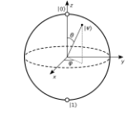
Figure 1. The Bloche sphere
Therefore, the state of the qubit can be uniquely described using two angles: $θ$ and $φ$. And this form of representing the state of the emulated qubit was adopted by the authors of this article.

Model architecture
This chapter will discuss the general architecture of the quantum bit model. In order to test the idea of the model, the entire functional set of the system was designed. It consists of a proper qubit emulator called QUBIT and a device adapted to generate and measure electric digital pulses called GENMET (GENerator-METer).
In addition to these two main elements, the set also includes: a monitor, an external generator, an oscilloscope and a simulation management computer. It is schematically shown in Figure 2. The proposed system emulates the behavior of a virtual qubit in real time and graphically displays the Bloch sphere on the monitor screen along with a vector representing the current state of this qubit. The user has the ability to rotate the qubit’s state vector with appropriate input digital pulses, while at the same time the emulated qubit continuously generates its own digital output signals proportional to its current state. Thanks to this, the user has the constant opportunity to observe and read parameters of the qubit, such as its phase and superposition state, which is not directly possible in real quantum systems. Additionally, digital pulses fed into and received from the emulator’s outputs can be continuously monitored on the attached oscilloscope.
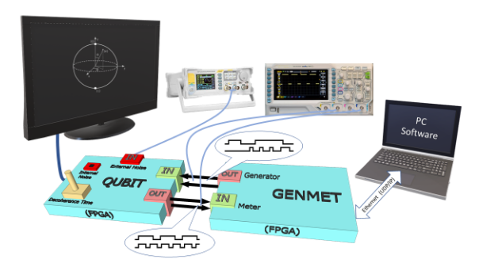
Figure 2. The system idea
QUBIT is also equipped with modules that emulate real physical disturbances. For this purpose, both the internal natural noises of the FPGA system (on the basis of which the emulator was created) are used, as well as special additional circuits that allow the qubit to be disrupted with a user-defined signal generated on an external function generator. Thanks to this, the user can test his quantum operations (algorithms) in the presence of a given interference waveform. It can be, for example, a sinusoidal signal of any frequency, but also white noise or another signal composed of many other harmonic waveforms. In particular, frequency, amplitude or phase modulated signals can be used.
Additionally, to ensure conditions of using the qubit emulator that are close to real ones, the emulator is equipped with a module that controls the qubit coherence time. Thanks to it, the user can set the time after which the qubit will be automatically measured and will lose its quantum state. This situation occurs when working with real quantum systems. For this reason, the user must develop quantum algorithms in such a way that they can be calculated before the system decoheres. The built-in decoherence management module is intended to enable the simulation of this type of situation.

QUBIT architecture
The QUBIT module, built on the basis of a programmable FPGA integrated circuit, is the main element of the system. It emulates the behavior of a qubit. The state of a qubit is represented by two angles: THETA and PHI. The THETA angle describes the state of superposition of the base states, and the PHI angle determines the phase of the |1⟩ state in relation to the |0⟩ state. The block diagram of the QUBIT module architecture is presented in Figure 3.
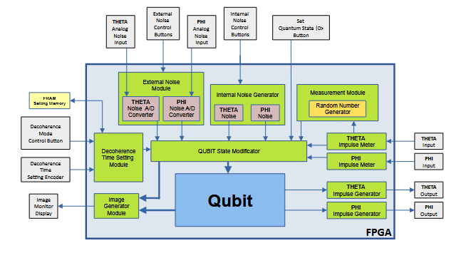
Figure 3. The QUBIT architecture

The QUBIT device is equipped with circuits responsible for handling internal and external noises and with a circuit responsible for emulating the phenomenon of quantum decoherence. The coherence time is set using a dedicated encoder and is stored in the non-volatile FRAM (Ferroelectric Random-Access Memory). The device is also equipped with an image generator that shows the qubit state marked on the Bloch sphere on the monitor screen. The main interaction with the qubit is through the THETA and PHI inputs and outputs.
To reset the THETA angle to zero, i.e. set the qubit to the quantum state |0⟩, a pulse with a length ranging from 9000 $μ$s to 9100 $μ$s (microseconds) must be applied to the THETA digital input.
To hide the qubit state vector in the Bloch sphere, a pulse with a length ranging from 9500 $μ$s to 9600 $μ$s must be applied to the THETA digital input. To restore the visibility of the state vector, a pulse with a length ranging from 9700 $μ$s to 9800 $μ$s must be applied to the THETA digital input.
To rotate the THETA angle by a specific positive angle $α$, a pulse with a length $T$ [$μ$s] equal to the desired angle expressed in tenths of a degree should be sent to the THETA digital input, i.e. according to the formula:
$$T= ∝ ∙10 \left[μs\right]$$
To rotate the state vector “along” the THETA angle by a specific negative angle $α$, a pulse of length T [$μ$s] must be sent to the THETA digital input, equal to the angle $α$ expressed in tenths of a degree and increased by an additional 4000 $μ$s, i.e. according to the formula:
$$T=4000+ α∙10\left[μs\right]$$

For example:
- an angle change of $+{43.7}^{∘}$ requires a pulse length of 437 $μ$s,
- an angle change of $-{43.7}^{∘}$ requires a pulse length of 4437 $μ$s,
- an angle change of $-{143.7}^{∘}$ requires a pulse length of 5437 $μ$s.
To measure the qubit, a pulse with a length between 8000 $μ$s and 8100 $μ$s must be applied to the THETA input. After this operation, the qubit is set to position |0⟩ or position |1⟩, according to the probability represented by the angle $θ$ (THETA).
To zero the PHI angle, i.e. set the qubit phase to 0 degrees (0◦), a pulse with a length ranging from 9000 $μ$s to 9100 $μ$s (microseconds) must be applied to the PHI digital input.
To rotate the qubit phase “along” the PHI angle by a specific positive angle $α$, similarly to the THETA angle, send a pulse of length $T$ [$μ$s] to the PHI digital input, equal to the desired angle expressed in tenths of a degree, i.e. according to the formula:
$$T=α∙10\left[μs\right]$$
To rotate the qubit phase “along” the PHI angle by a specific negative angle $α$, a pulse of length $T$ [$μ$s] must be sent to the PHI digital input, equal to the angle $α$ expressed in tenths of a degree and increased by 4000 $μ$s, i.e. according to the formula:
$$T=4000+α∙10\left[μs\right]$$
For example:
- an angle change of $+{45.1}^{∘}$ requires a pulse length of 451 $μ$s,
- an angle change of $-{45.1}^{∘}$ requires a pulse length of 4451 $μ$s,
- an angle change of $-{245.3}^{∘}$ requires a pulse length of 6453 $μ$s.
The next ports in the QUBIT module are two digital outputs PHI and THETA, where appropriate electrical impulses are generated continuously and proportionally to the current state of the modeled qubit. The generated pulses for θ = 30◦ and ϕ = 45◦ are shown in Figure 4. A non-destructive reading of the current quantum state of the qubit involves measuring the length of the pulses generated at the THETA and PHI outputs. The lengths of these pulses show the values of the corresponding angles, expressed in tenths of a degree, minus one.
Therefore, in order to correctly read the THETA and PHI angles, the pulse lengths ($T$) measured in microseconds should be reduced by 1 and then divided by 10, i.e. according to the formulas:
$$THETA=\frac{T_{THETA}-1}{10} \left[​^{∘}\right], PHI=\frac{T_{PHI}-1}{10} \left[​^{∘}\right]$$

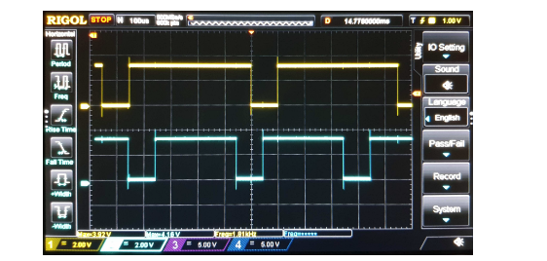
Figure 4. The pulses for $θ=30°$ (blue) and $∅=45°$ (yellow)
For example:
- The measured pulse of 743 $μ$s indicates an angle of 74.2$​^{∘}$
- The measured pulse of 1 $μ$s indicates an angle of 0$​^{∘}$
In “Decoherence Mode”, the QUBIT module behaves like a real qubit not fully isolated from its surroundings. After switching this mode, information about the currently selected qubit coherence time and information about how much time is left until the system decoheres, appears in the upper right corner of the monitor screen. An example monitor screen in this mode is shown in Figure 5.
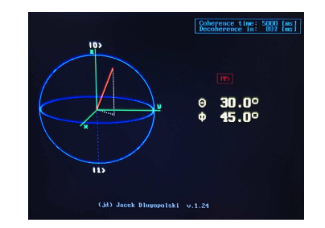
Figure 5. The monitor screen in the decoherence mode
The time during which the qubit is maintained in the quantum state (coherence time) can be changed by the user in the range from 1 ms to 9000 ms with a resolution of one millisecond using a dedicated encoder knob (the current setting is continuously saved in the non-volatile FRAM memory and is remembered after the power is turned off). This function only works in automatic decoherence mode, i.e. after switching the appropriate switch in the QUBIT module. In this mode, once the qubit has been set to a quantum state, it will automatically decohere after a time set according to the procedure discussed above. This will be equivalent to taking a measurement on it. After decoherence, its classical state will be either “0" or “1", according to the probabilities of the current quantum state just before decoherence. Any operations on the qubit will then no longer work until it is next set to the quantum state.
Another important function of the designed QUBIT is the “Noise" mode, in which the current quantum state of the qubit can be disturbed either by natural noise coming from the internal circuits of the FPGA or by noise artificially generated via an external function generator. Appropriate switches allow you to select the noise source. After turning on the “Noise" mode, a dedicated frame appears on the screen informing about this fact (Fig. 6).
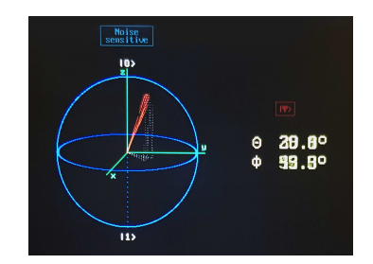
Figure 6. The monitor screen in the noise mode
Then, appropriate switches allow you to turn individual noises on and off, separately for each state component: THETA and PHI.

