Jan Adam Nowak

TITLE: SAMPLE FOR “ZADANIE 2” – DEGREE OF DIFFICULTY 21–40%

Abstract: Unexpected rockfalls and rock displacements belong to most significant dangers related to slope engineering. It may cause not only serious changes in the environment but also, and most of all, danger for infrastructure and can even lead to fatal accidents. Therefore, ensuring security in both open-pit mining and on the rocky slopes in the area of road cuts requires instant monitoring of the stability and displacements of slopes and determining the dynamics of emerging changes. Dynamic development of surveying technologies including Terrestrial Laser Scanning (TLS) allows fast retrieval of measurement data. The additional advantage of TLS is its ability to quickly obtain data of very high resolution and accuracy without direct contact with the examined object. Thus, it allows to carry out measurements for the whole object without the need for generalization. It offers new possibilities for analysis and interpretation of obtained results. This paper presents the possibilities of using TLS method for marking displacements and volume of rock cavities formed as a result of natural and anthropogenic weathering. Discussed works are supported by exemplary measurements conducted in the area of abandoned limestone quarry “Zakrzówek” in Cracow.

Keywords: surveying technology, terrestial laser scanning, volume of rock cavities, rock geometry measurements

Received: 1 January 2022; accepted: 19 February 2022

© 2021 Author(s). This is an open access publication, which can be used, distributed and reproduced in any medium according to the Creative Commons CC-BY 4.0 License.

- INTRODUCTION
Unexpected rockfalls and rock displacements belongs to most significant dangers related to slope engineering. It may cause not only serious changes in the environment but also, and most of all, danger for infrastructure and can even lead to fatal accidents. Therefore, ensuring security in both open-pit mining and on the rocky slopes in the area of road cuts requires instant monitoring of the stability and displacements of slopes and determining the dynamics of emerging changes [1–3]. Dynamic development of surveying technologies including Terrestrial Laser Scanning (TLS) allows fast retrieval of measurement data. The additional advantage of TLS is its ability to quickly obtain data of very high resolution and accuracy without direct contact with the examined object. Thus, it allows to carry out measurements for the whole object without the need for generalization. It offers new possibilities for analysis and interpretation of obtained results [4].
This paper presents the possibilities of using TLS method for marking displacements and volume of rock cavities formed as a result of natural and anthropogenic weathering. Discussed works are supported by exemplary measurements conducted in the area of abandoned limestone quarry “Zakrzówek” in Cracow [5, 6].

2. THE STUDY OF MEASUREMENT DATA
Simultaneously, due to installing the ground control points on the examined object, it was very significant to check its relative stability between subsequent measuring sessions. Therefore, after each session the least square isometric transformation of coordinates obtained from tacheometric measurement and scanning the initial coordinates of the network was conducted in order to detect prospective relative displacements of the network. Considering the character of the object, the analysis was conducted in object local coordinate system. It allowed to avoid the impact of distortion and errors connected with tying measurements to state coordinate system on the results. Obtained differences are presented in Table 1.

Table 1. Testing the stability of control point
Session | Target ID | Total station |  |  |  | TLS |  |  |  | TLS (after reduction)
Session | Target ID | vX [mm] | vY [mm] | vH [mm] | mP [mm] | vX [mm] | vY [mm] | vH [mm] | mP [mm] | vX [mm] | vY [mm] | vH [mm] | mP [mm]
1 | 201 | – | – | – | – | −3 | −3 | 2 | 5 | 1 | 1 | 2 | 3
1 | 202 | – | – | – | – | −1 | 4 | 2 | 4 | 0 | 0 | −2 | 2
1 | 203 | – | – | – | – | −2 | −2 | 0 | 3 | −1 | −1 | −1 | 1
1 | 204 | – | – | – | – | 6 | 2 | −4 | 7 | 0 | 0 | 0 | 0
2 | 201 | −2 | −2 | 1 | 3 | −4 | −5 | 2 | 6 | −1 | 0 | 2 | 2
2 | 202 | −1 | 2 | 1 | 2 | −1 | 4 | 3 | 5 | 0 | −1 | −1 | 1
2 | 203 | 0 | 0 | 0 | 0 | −3 | −2 | −1 | 3 | −1 | −1 | −2 | 2
2 | 204 | 2 | 1 | −2 | 3 | 7 | 3 | −4 | 9 | 2 | 1 | 0 | 2
3 | 201 | −2 | −5 | −2 | 6 | −3 | −5 | −3 | 6 | 1 | −1 | −2 | 2
3 | 202 | −2 | 3 | 2 | 4 | 0 | 5 | 5 | 7 | 1 | 1 | 2 | 2
3 | 203 | 1 | 3 | 1 | 3 | −2 | 0 | 2 | 3 | 0 | 1 | 1 | 2
3 | 204 | 3 | −1 | −1 | 3 | 4 | 0 | −4 | 6 | −1 | −2 | −1 | 2
4 | 201 | 0 | −1 | −3 | 3 | −4 | −5 | −3 | 7 | −1 | 0 | −3 | 3
4 | 202 | −1 | 2 | 3 | 3 | −1 | 5 | 4 | 6 | 0 | 0 | 1 | 1
4 | 203 | 1 | −1 | 1 | 1 | −1 | −1 | 2 | 2 | 1 | 0 | 1 | 2
4 | 204 | 1 | 0 | 0 | 1 | 5 | 2 | −3 | 6 | −1 | 0 | 1 | 1
 |  |  | Average |  | 3 |  | Average |  | 5 |  | Average |  | 2
 |  |  | Std. deviation |  | 1 |  | Std. deviation |  | 2 |  | Std. deviation |  | 1

The results obtained by comparing tacheometric measurements from all sessions allow to conclude that the network was constant during the measurement. The average value of coordinate differences did not exceed 3 mm. Taking into consideration surveying equipment that was used, this value has to be regarded as measurement error. Analysing the results obtained from comparison of scanning and tacheometric measurement results, systematic error in a laser scanner can be noted. The corrections on particular points take similar values for subsequent measurement sessions. It may indicate instrumental errors in a laser scanner. After eliminating the systematic errors, the results of coordinate differences reached less than 3 mm, which shows high reproducibility of scanning measurement. Additional conclusion that derives from this analysis is that the examination of control points stability can be successfully performed with the use of a laser scanner. It should be noted that the instrument used for this purpose has to be fully calibrated. After establishing the constancy of control points, it was possible to conduct transformation of the whole point clouds to the homogenous coordinate system. In order to do that, the registration of point clouds into the coordinates from least square adjustment was performed in Leica Cyclone 7.3. Mean registration error ranged from 2 to 4mm depending on measurement session.

3. METHODS OF COMPARING POINT CLOUDS AND THEIR ACCURACY
TIN model comparison method is most frequently used. Thanks to the use of Triangular Irregular Network deformation values are measured alongside the normals for particular triangles, which enable determining the sign of deformation and gives reasonably accurate and realistic results. Simultaneously, this method allows to determine deformations in the objects with irregular structure and is independent from point cloud density variable. Inaccuracies caused by inadequate filtering of source point clouds emerging while creating a model may create problems. Even individual outliers may negatively influence the accuracy of the study. It results in a false image of deformation in which it is impossible to indicate incorrect point, which inhibits further study of the results. What is more, all analytical processes require substantial memory resources and processing power of a computer, especially with larger databases.
Another approach to examine object displacements are the analyses based on comparing raw data, i.e. C2C method. They are based on approximating the distance from the compared cloud to local modeling reference cloud surface.
The biggest advantages of C2C methods are listed below:
- direct operating on the set of points provides the values of deformation for particular points,
- they require far less processing power, comparing to the methods based on TIN,
- they are more resistant to the occurrence of outliers.
In order to assess the accuracy and effectiveness of particular methods, the analysis of laboratory case object was conducted. The comparison of point clouds was performed with the use of CloudCompare v2.6.1 program for which the radius of local modeling was defined as 10 cm for all methods. This value allowed the best preservation of irregular structure of the object. On the other hand, the comparison of TIN models was performed in Geomagic Studio 12 program. Detailed results (differences between clouds of the third and fourth series) obtained for respective methods are presented in Table 2.

Table 2. Volumes of emerging rock cavities calculated for point clouds of different densities
. | Positive [m³] | Negative [m³] | Net [m³] | Area [m²] | Relative error [m²/m²]
 |  |  |  |  | positive | negative
Original | 0.061 | 0.094 | −0.033 | 67.5 | 0.0009 | 0.0014
10 mm | 0.064 | 0.091 | −0.027 | 67.5 | 0.0009 | 0.0013
25 mm | 0.066 | 0.097 | −0.031 | 67.5 | 0.0010 | 0.0014
50 mm | 0.088 | 0.132 | −0.044 | 67.5 | 0.0013 | 0.0020
100 mm | 0.12 | 0.167 | −0.047 | 67.5 | 0.0018 | 0.0025
Avg. | 0.080 | 0.116 | −0.036 | – | 0.0015
Std. dev | 0.022 | 0.029 | 0.008 | – | 0.0005

Laboratory case object is characterized by solid structure; therefore, it was assumed that expected compared values should be close to zero. Figure 1 shows the results obtained from different methods of comparing point clouds with maximum density (5 mm), which are presented for the fragment of test object.

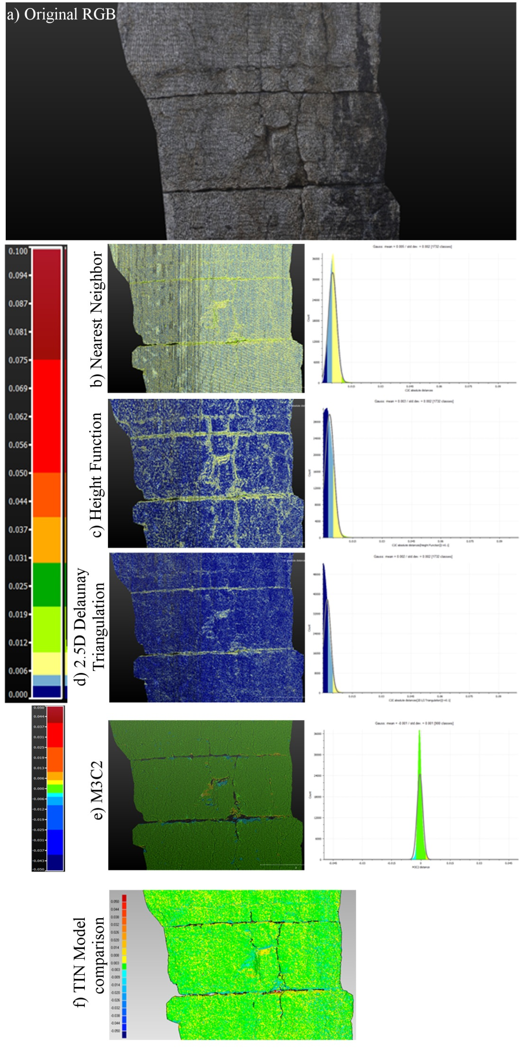
Fig. 1. Results of clouds comparison with different methods

Afterwards, the changes of volumes for the whole object and four areas with major changes were calculated. The calculations were performed for all combinations of measurement series. On the basis of positive volumes, which were considered to be caused by measurement errors and filtering, relative volume error and error limit value for significant changes were calculated.
These values were calculated as:
$$S_{v}=\left(R_{e}+2,5*S_{d}\right)*A,$$
where:
S_{v} – significant value [m³],
R_{e} – relative error [m³/m²],
S_{d} – standard deviation calculated from all relative errors [m³/m²],
A – calculated area [m²].
Relative error value was assigned as quotient of positive volumes and surface area obtained for all compared areas and combination of compared session. Thus, 30 values (five compared areas and six combination of compared session) for object no. 2 and 24 (four compared areas and six combination of compared session) for object no. 3 was determined. After that average value and it standard deviation was calculated and used to determine the limit error of significant error.

- RESULTS
After establishing all parameters of accuracy of conducted measurements for the test object, two remaining areas were examined. However, before comparing them, it was necessary to filtering the point clouds from vegetation situated on the object in the first place. In order to obtain best results, manual filtering was carried out in Leica Cyclone program. Subsequently, the comparison of distances between point clouds for object no. 2 was performed (Figs. 2, 3).
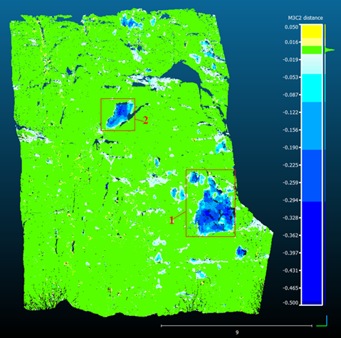
Fig. 2. Object no. 2 – comparison of first and second session
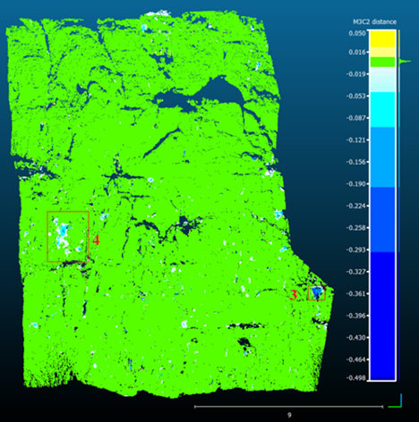
Fig. 3. Object no. 2 – comparison od third and fourth session

This comparison enables indication of significant cavities which developed between first and second measurement session and reach up to 50 cm. Furthermore, a few smaller but significant cavities were detected between third and fourth session. No significant deformations were noticed between second and third session. It is worth pointing out that it is possible to observe single, minor cavities of even 1 cm. Whereas for the orthoimage generated using the DEM LPIS model, the deviation value is more sensitive to terrain shape and it is the smallest in case of flat urban area (Fig. 4).

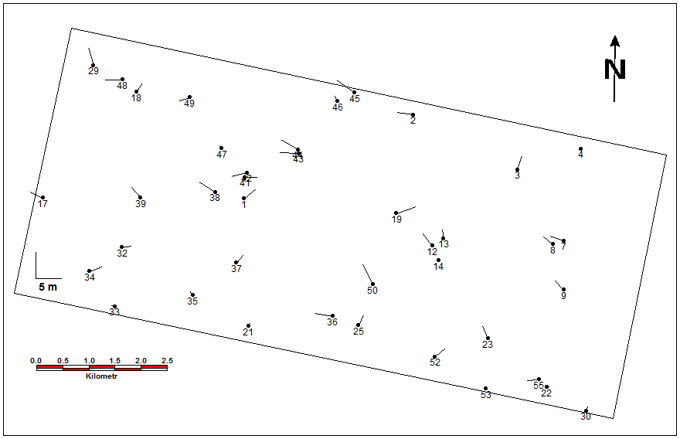
Fig. 4. Check points deviations for TSX-2 orthoimage generated based on one point and DTED-2 model

The TerraSAR-X products are different depending on the geometric projection and processing level:
- Single Look Slant Complex (SSC). A basic single look product of the focused radar signal in slant range geometry. Data is represented as complex numbers containing information about intensity and phase of registered signal. This kind of data is necessary in case of SAR interferometry (InSAR).
- Multilook Ground Range Detected (MGD). A multilook detected product with reduced speckle after a simple polynomial slant to grant projection using a WGS84 ellipsoid and an avarage terrain height.
- Geocoded Ellipsoid Corrected (GEC). A multilook detected product after the ellipsoid correction, projected and resampled to UTM (or UPS in polar regions). The ellipsoid correction does not consider a DEM but WGS84 is used as geodetic reference assuming one average terrain height.
- Enhanced Ellipsoid Corrected (EEC). A multilook detected product after the terrain correction, projected and resampled to UTM (or UPS). All terrain distortions are corrected using a DEM, usually SRTM.
- Geocoded Terrain Corrected (GTC). A multilook detected product after the terrain correction, to which an external high-resolution DEM and ground control points are used. As other detected products, it is projected and resampled to UTM or UPS.

- CONCLUSIONS
On the basis of obtained results, laser scanning method may be considered as highly useful for measuring the volume and deformations of rock cavities. It allows for marking deformations even with accuracy of a few millimetres and, at the same time, provides the full image of developed changes. However, it has to be noted that in order to obtain reliable results, the maximum reproducibility of conducted measurements and adequate method of point cloud comparison has to be adopted. At the same time, it is possible to precisely define the volume of remaining cavities. In this case, the best solution is to carry out the measurements only for the areas where the cavities were previously identified.

ACKNOWLEDGEMENTS
The study was performed in the Department of Environmental Management and Protection and financed by research project no. 12.34.56.XXX.

REFERENCES
[1] Zagrożenia naturalne w odkrywkowych zakładach górniczych. Wyższy Urząd Górniczy, Katowice 2007.
[2] Girard J.M.: Assessing and monitoring open pit mine highwalls. [in:] Proceedings of the 32nd Annual Institute on Mining Health, Safety and Research, Salt Lake City, Utah, August 5–7, 2001, University of Utah, Salt Lake City 2001, pp. 159–171.
[3] Hearn G.J.: Slope Engineering for Mountain Roads. Geological Society Engineering Geology Special Publication, vol. 24, Geological Society of London, London 2001.
[4] Olek B., Woźniak H., Stanisz J.: Statistical methods used for determining geotechnical parameters. Przegląd Geologiczny, r. 62(10/2), 2014, pp. 657–663.
[5] Motyka J., Czop M.: Vertical Changes of Iron and Manganese Concentration in Water from Abandoned “Zakrzówek” Limestone Quarry near Cracow (South Poland). [in:] Mine water and the environment: proceedings of the 10th IMWA congress 2008: 2–5 June, 2008, Karlovy Vary, Czech Republic, VSB – Technical University of Ostrava, Ostrava, pp. 167–170.
[6] Alba M., Fregonese L., Prandi F., Scaioni M., Valgoi P.: Structural monitoring of large dam by terrestrial laser scanning. [in:] Maas H.-G., Schneider D. (eds.), Proceedings of the ISPRS Commission V Symposium “Image Engineering and Vision Metrologyˮ: September 25–27, 2006 Dresden, Germany. https://www.isprs.org/proceedings/XXXVI/part5/paper/1271_Dresden06.pdf [access: 1.01.2021].
[7] Lague D., Brodu N., Leroux J.: Accurate 3D comparison of complex topography with terrestrial laser scanner: application to the Rangitikei canyon (N−Z). ISPRS Journal of Photogrammetry and Remote Sensing, vol. 82, 2013, pp. 10–26. https://doi.org/10.1016/j.isprsjprs.2013.04.009.
[8] CloudCompare version 2.6.1: User manual. http://www.cloudcompare.org/doc/qCC/CloudCompare%20v2.6.1%20-%20User%20manual.pdf [access: 1.01.2021].
[9] Girardeau-Montaut D., Roux M., Marc R., Thibault G.: Change detection on points cloud data acquired with a ground laser scanner. [in:] ISPRS Workshop Laser Scanning 2005: Enschede, the Netherlands, 12–14 September 2005, GITC, pp. 30–35.

AGH University of Science and Technology, Faculty of Geo-Data Science, Geodesy, and Environmental Engineering, Krakow, Poland, e-mail: jan.adam.nowak@agh.edu.pl, ORCID ID: https://orcid.org/0000-0002-9079-593Y

