Jan Nowak

TITLE: SAMPLE FOR “ZADANIE 1” –
DEGREE OF DIFFICULTY 66–80%

Coal mining in Upper Silesian Coal Basin (USCB) is conducted in the conditions of frequent mining tremors. The longwall roof support significantly impacts the safety and efficacy of the mining process. The paper presents the assessment of mining tremor hazard, the procedure of designing powered roof supports used in the conditions of tremors, and a method of evaluating supports’ resistance to dynamic overloads. The research was based on analyses carried out by the authors on the data collected during the works carried out by the Department of Extraction Technologies, Rockbursts, and Mining Support. The data was analysed using descriptive statistics.

Key words: powered roof support, dynamic overloads, mining tremor hazard

1. INTRODUCTION
Powered roof supports are placed on the market in compliance with the requirements of European Union Directives A new powered roof support (PRS) must fulfil the requirements of European Union Directives and harmonized Polish standards. The basic standards of the EN 1804 series that define the mechanical requirements for PRS exclude their application in areas threatened with mining tremors. Polish standards are complemented by the current regulations on occupational health and safety of the relevant Minister [1]. They introduce the requirement for the PRS to be especially protected in conditions of mining tremors hazard. Part of the protection strategy is to determine the safe range of support operation height and to select overload protection means for specific mining and technical conditions [2]. One of the most common methods protecting against dynamic overload involves installing hydraulic valves that limit the pressure in the leg piston space to an acceptable level considering the mechanical strength of a given structure. In other words, the support needs to yield when the dynamic phenomenon occurs.
The yielding protection method used by the Central Mining Institute (GIG) is an analytical method based on selected parameters:
- mining parameters – n_{tz} load coefficient and g roof bearing capacity index;
- operational parameters;
- technical parameters of the support − kinematics, diameters of the legs used, load bearing capacity: initial, working, nominal; k safety factor coefficient and protection applied by hydraulic valves.
In this paper, the current state of the operating powered roof support has been described using statistical methods. The analysis was focused on PRS technical parameters and operational conditions, based on the collected database for the years 2016–2019.

2. POWERED ROOF SUPPORT DESIGN
IN THE CONDITIONS OF TREMOR HAZARD
Overload can be defined as the “exceeding of the instantaneous nominal load of the support and its components by more than 50% due to rock mass tremors”. The adopted definition is consistent with the provisions of the Polish standard PN-EN 1804-1,2,3+A1 and literature [3].
The consequences of overload include primarily a loss of functionality of the support and its components (steel structure, hydraulic legs, and hydraulics control system) or a threat to overall operational safety (e.g., uncontrolled convergence).
Overload assessment is carried out according to the method developed by GIG as an implementation of the Regulation of the relevant Minister in the field of adaptation of the powered roof support to take over the dynamic loads [1]. Its aim is to determine the safe range of support operation height and to select overload protection for specific geological-mining and technical conditions of support operation [2].
The yielding method used by GIG is an analytical method based on selected mining parameters (n_{tz} load coefficient, roof bearing capacity index “g”) as well as operational and technical parameters of the support and its protection.
The n_{tz} load coefficient defines the increase in the support load due to rock mass tremor with respect to the static load. It depends on the distance from the hypocentre of the tremor to the roof of the longwall and the predicted maximum energy of the tremor. The variability of the n_{tz} index ranges from 1.0 to 1.8 m, according to [4]. The n_{tz} load coefficient is also an important parameter used in determining the roof bearing capacity index “g” [5–10]. The roof bearing capacity index “g” defines the roof maintenance conditions:
- “g” < 0.7 – caving hazard (the powered roof support does not have a sufficient reserve of support to properly secure the excavation);
- 0.7 ≤ “g” < 0.8 – difficult roof maintenance conditions (although the use a powered roof support in a specific excavation is allowed, it must be remembered that limitations or difficulties in the excavation roof maintenance may occur);
- “g” ≥ 0.8 – proper roof maintenance conditions (the support is properly suited to a specific excavation).
For conditions where frequent tremors may occur, it is recommended that the “g” indicator be ≥ 0.8, which ensures correct maintenance of the roof. However, it should be noted that the correlation between the “g” index and the n_{tz} load coefficient is not a linear function and must be considered individually for each case of a new longwall and powered roof support.
The degree of mining tremor hazard in the case of a longwall excavation based on the value of the n_{tz} load coefficient can be determined as shown in Table 1.

Table 1. The degree of mining tremor hazard in the case of a longwall excavation based on the value of the n_{tz} load coefficient [4]
Load coefficient n_{tz} | 1.0–1.1 | 1.0–1.1 | 1.2–1.3 | 1.3–1.4 | >1.4
Hazard to the excavation | lack | weak | medium | strong | very strong

The values of the n_{tz} load coefficient in the years 2016–2019 are shown graphically in Figure 1. The data encompasses 266 cases of longwalls excavated under the conditions prevailing in USCB, analysed by the Central Mining Institute as part of research and development works commissioned by mines and roof support manufacturers. The cases concerned the design of a powered roof support and determination of conditions of its protection under specific geological and mining conditions.

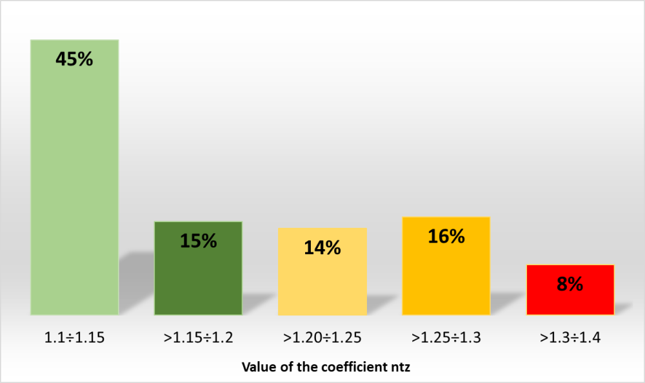
Fig. 1. Load coefficient n_{tz} in the years 2016–2019 by GIG

The above data demonstrates that 29% of the longwalls are operating under conditions of medium tremor hazard, and 8% – high mining tremor hazard. Considering that the mining operations in USCB will be conducted at deeper levels and the tremor hazard tends to intensify with increasing depth, it should be concluded that the percentage of longwalls with a high risk of rock mass tremors will be higher.
GIG’s yielding protection method is based on the disturbed rock mass model developed by A. Biliński and the flat model of support with concentrated constants and one degree of freedom. The following dependencies are applied [2, 4, 11–13]:
$f\left(t\right)=\frac{1}{\cos{(}90-α)}\left(F_{w}+F_{d}(1+k_{d}e^{-δt}\sin{(}ωt-φ))\right), N$ (1)
where:
f(t), F_{w}, F_{d} – forces, respectively: leg, initial and dynamic load [N],
δ – system damping factor [s⁻¹],
k_{d} – calculation factor,
ω – angular velocity [rad∙s⁻¹],
φ – angle of force shift in the leg in relation to the loading force [rad],
α – angle of inclination of the leg in relation to the floor base [°].
Here, the maximum force is calculated for each case and refers to the nominal capacity of the leg, for a given working height, the value of the n_{tz} indicator and the flow in the overload protection system.
In addition, in the case of roofs which are difficult to be caved (which do not cave-in behind the powered supports line), it is proposed to carry out additional calculations using the evaluation of the force of the rock mass-section system according to dependence (2) [4, 14], in order to check the flows in the system protecting the leg:
$Q_{u}≥\frac{F_{r}\left({n_{tz}}^{2}-n_{tz}\right)}{2P_{r}cosα}∙6∙{10}^{4}$ (2)
where:
Q – flow in the leg protection system [dm³∙min⁻¹],
F_{r} – working bearing capacity of the roof support [N],
n_{tz} – load coefficient [–],
P_{r} – nominal bearing capacity of the leg [N].

3. PERFORMANCE AND TECHNICAL PARAMETERS
OF CURRENTLY USED POWERED ROOF SUPPORTS
In the years 2016–2019, the Department of Extraction Technologies, Rockbursts and Mining Support, GIG, has carried out over 550 research and development works, including 266 works concerning the determination of the support protection by yielding and its application in specific geological and mining conditions.
The analysis of studies concerning the powered roof support applied in seams with tremor hazard shows that the support most frequently used in USCB is shield support with two hydraulic legs. The most popular are double-telescopic hydraulic legs with a bottom valve, and their share in the whole analysed group is as much as 73% (Fig. 2).
Single-telescopic legs with a mechanical extension are used less frequently, but their share is still substantial (16%). They are followed by double-telescopic legs (7%) with the so-called third piston. The remaining 5% are whose share in the group was the smallest, including double-telescopic legs with a bottom valve and a mechanical/hydraulic extension, as well as legs with a floating piston.

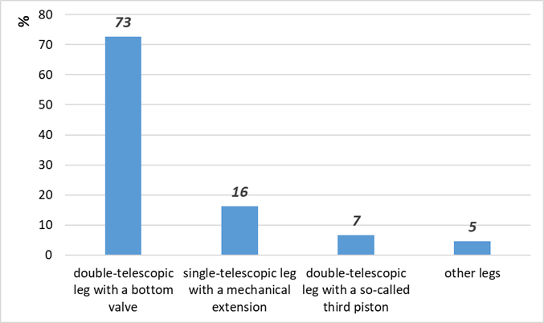
Fig. 2. Percentage share of various types of legs of the powered roof support used in 2016–2019

The percentage division of double-telescopic legs according to their first-degree diameter in the analysed set is shown in Figure 3.

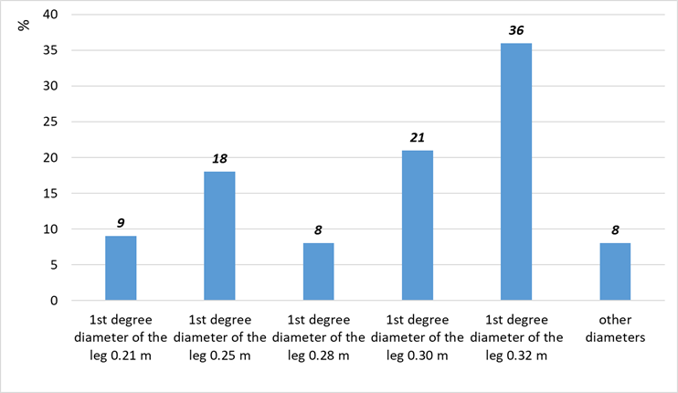
Fig. 3. Percentage share of double-telescopic legs with the first-degree diameter in the analysed set

Currently, the most commonly used legs in the mines of USCB are those with first-stage diameters equal to 0.30 and 0.32 m, which is related to deteriorating geological and mining conditions. A large group are also legging with a diameter of 0.25 m, which is related to repairs of previously operated roof supports.
More than 60% of ongoing mining activity takes place in the conditions of tremor hazard, which is confirmed by the fact that mines increasingly often purchase powered roof supports with legs having diameters of ≥0.30 m, in order to obtain a greater load-bearing capacity for the supports and ensure proper conditions for maintaining the longwall roof.
The remaining 8% of the analysed cases, are legs with rarely applied diameters, i.e., 0.255 m; 0.265 m; 0.275 m; 0.29 m (usually post-repair legs), as well as new roof supports on the market, which include higher diameters: 0.37 m; 0.38 m; 0.39 m; 0.40 m; 0.42 m.
It is estimated that due to increasing mining depth, legs with diameters of ≥0.37 m will be more widely used in the future, and their percentage share will increase significantly.
As regards single-telescopic legs with a mechanical extension, most of the legs that are currently applied in USCB conditions are those with diameters of 0.20 and 0.25 m, as shown in Figure 4.

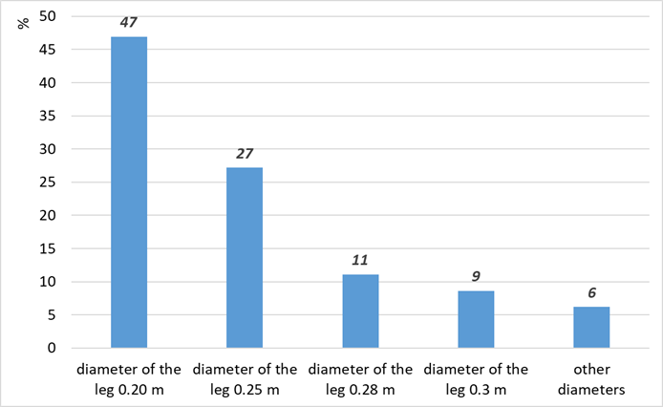
Fig. 4. Percentage share of single-telescopic legs in the analysed set by their diameter

The percentage share of legs in the collective analysis by the value of overload factor in the full (type) test at the time of their placement on the market is shown in Figure 5.

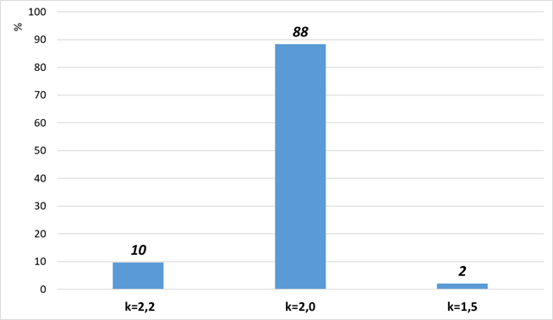
Fig. 5. Percentage of legs of powered roof supports by the value of overload factor in the full test

The supply pressure of the support is between 25.0 and 32.0 MPa. Currently, over 90% of all roof supports used in USCB are supplied with 25.0 MPa. In individual cases, the support is supplied with a higher pressure, which most often results from the need to maintain proper roof conditions (“g” index ≥ 0.8).
Important elements of the powered roof support designed to work in the conditions of mining tremors are: a hydraulic control system, protection against overload and operational parameters. Studies on the introduction of the electrohydraulic control system for longwall shearers which has been developed in Poland are in progress; the solutions are likely to be implemented in the coming years [15]. Systems for monitoring the operating parameters of the PRS are being promoted and almost every new support is already equipped with such a system [16, 17]. The legs are protected against overload by using high-capacity valves, the values of which are usually specified in studies on the yielding capacity of supports operating in the conditions of mining tremor hazard.

5. CONCLUSIONS
A powered roof support is one of the basic elements of the longwall system. Its proper operation has a significant impact on the efficiency and efficacy of the extraction process, as well as on general safety in the longwall. The longwall equipment usually consists of approximately 100–150 supports. The most common type of supports used in USCB mines is the shield support, and the most popular leg is the double-telescopic type with a bottom valve. The diameter of the first stage of the leg ranges from 0.2 to more than 0.4 m, which results in more than four-time difference in the value of the applied load bearing capacity. The legs are protected against overload by hydraulic valves with appropriately selected flow rates [4, 18].
The new powered roof supports are equipped with legs having diameters of minimum 0.30 m. The smallest diameters are most frequently applied in the legs of older supports manufactured before Poland’s accession to the European Union.
Currently, powered roof supports are produced in compliance with EU regulations. If the supports are designed to operate in the conditions of mining tremor, they must additionally meet the requirements resulting from the OSH regulation on yielding protection of issued by the relevant Minister [1] which requires the support to take over the additional load resulting from the tremors.
The Annual Report on the State of Basic Natural and Technical Hazards in Hard Coal Mining in 2018 [19] stated that the total output from the longwalls classified as threatened by tremors amounted to approximately 54% of the total volume of output in Polish mines. Since the classification of a seam into an appropriate tremor hazard group is not a measure of the occurrence of high-energy rock mass tremors, it should be assumed that rock mass tremors currently affect more than 60% of the exploited seams. The degree of tremor hazard is assessed as medium, but in a few cases, it is much higher. The yielding is assessed by the Central Mining Institute according to its own method, on the basis of documents provided by the ordering party.
High variability of geological and mining conditions as well as the necessity to relocate powered roof supports in the area of USCB are a premise for unifying the construction of supports (limitation of the number of varieties) and placing on the market only the ones that are prepared for operation in areas with mining tremor hazard.
The application of new supports with first-stage legs having diameters of more than 0.32 m has significantly reduced the possibility of performing tests under dynamic load, due to the limited technical capabilities of the leg. It is proposed to develop numerical methods and bench tests on reduced-scale models that will complement them.
In this paper, a set of data resulting from research and development works commissioned to the Central Mining Institute by mines and manufacturers of roof supports is analysed statistically. The resulting collection contains data for the years 2016–2019, and will be regularly updated.

REFERENCES
- Rozporządzenie Ministra Energii z dnia 23 listopada 2016 r., Dz.U. nr 2017, poz. 1118, §523 ust. 1, pkt 1.
- Rajwa S., Prusek S., Stoiński K.: Opis metody upodatnienia zmechanizowanej obudowy ścianowej, “Bezpieczeństwo Pracy i Ochrona Środowiska w Górnictwie” 2016, 12: 3–8.
- Zonn W. (red.): Kopernik, astronomia, astronautyka: przewodnik encyklopedyczny, Państwowe Wydawnictwo Naukowe, Warszawa 1973.
- Stoiński K. (red.): Zmechanizowane obudowy ścianowe dla warunków zagrożenia wstrząsami górotworu, Wydawnictwo GIG, Katowice 2018.
- Rajwa S. et al.: Statutory work GIG No. 12090577-152, 2007, GIG Katowice [unpublished].
- Prusek S., Rajwa S., Wrana A., Krzemień A.: Assessment of roof fall risk in longwall coal mines, “International Journal of Mining, Reclamation and Environment” 2016: 1–17.
- Prusek S., Rajwa S., Walentek A., Masny W.: Powered support selection for longwall workings in dynamic load conditions, “3rd International Symposium on Mine Safety Science and Engineering, Montreal” 2016: 13–19.
- Prusek S., Płonka M., Walentek A.: Applying the ground reaction curve concept to the assessment of shield support performance in longwall faces, “Arabian Journal of Geosciences” 2016, 9, 3: 1–15.
- Rajwa S., Masny W., Wrana A.: A comprehensive method for the selection of powered roof support in conditions of the rockburst hazard, “Wiadomości Górnicze” 2017, 1: 2–7.
- Rajwa S., Janoszek T., Prusek S.: Influence of canopy ratio of powered roof support on longwall working stability – A case study, “International Journal of Mining Science and Technology” 2019, 29, 4: 591–598.
- Biliński A., Kostyk T., Prusek S.: Zasady doboru obudowy zmechanizowanej dla wyrobisk ścianowych, “Bezpieczeństwo Pracy i Ochrona Środowiska w Górnictwie” 1997, 3: 14–17.
- Stoiński K.: Obudowy górnicze w warunkach zagrożenia wstrząsami górotworu, Wydawnictwo GIG, Katowice 2000.
- Prusek S., Rajwa S., Stoiński K.: Kriterien zur Abschatzung des Risikos von Strebschaden, “Glückauf-Forschungshefte” 2005, 11: 92–95.
- Szurgacz D.: Próba określenia dynamicznej mocy stojaka zmechanizowanej obudowy ścianowej przeznaczonego do pracy w warunkach zagrożenia wstrząsami górotworu – artykuł dyskusyjny, “Prace Naukowe GIG” 2011, 10: 79–87.
- Szurgacz D., Brodny J.: Research on the Effectiveness of the Actuating Element of the Electro Control System for the Powered Roof Support, “E3S Web of Conferences” 2018, 41: 03016.
- Jasiulek D., Bartoszek S., Lubryka J.: Efektywność wykorzystania i bezpieczeństwo techniczne górniczej obudowy zmechanizowanej – PRASS III, “Systemy Zasilania, Sterowania, Monitoringu i Diagnostyki” 2019, 1: 73–79.
- Szurgacz D., Brodny J.: Innovative visualization system designed to monitor parameters of mining systems operation, “Multidisciplinary Aspects of Production Engineering” 2018, 1, 1: 361–368.
- Stoiński K., Prusek S., Rajwa S.: Dobór przepływów w układzie zabezpieczającym stojak zmechanizowanej obudowy ścianowej – opis przypadku, XXIII International Conference TEMAG, Gliwice 2015.
- Kabiesz J. et al.: Raport Roczny (2018) o stanie podstawowych zagrożeń naturalnych i technicznych w górnictwie węgla kamiennego, Wydawnictwo GIG, Katowice 2019.

Jan Nowak, MSc., Eng.
AGH University of Science and Technology
al. A. Mickiewicza 30, 30-059 Krakow, Poland
j.nowak@agh.edu.pl

