Attachment No. 1 to SWZ
Description of the subject of the contract
The project aims to develop a concept for the launch of regular shipping along the international waterway E60. The concept includes technical, economic and social aspects to achieve the best possible economic impact.
The project formulates transport solutions supporting the active development of peripheral coastal regions of the South Baltic area, focusing on local ports as development centres. This helps increase the Baltic Sea Region's competitiveness and increase its accessibility and attractiveness. One of these solutions is a transport simulator, which is addressed especially to the business sector - cargo operators, logistics forwarders and other transport entities operating in this area.
The main results of the INCONE60 project are:
- Four comprehensive publications on the current socio-economic situation of regions located in the area of gravity of local/regional ports of the South Baltic. The reports contain the results of detailed research and analysis of the region's transport system and infrastructure (roads, railways, inland waterways, port infrastructure). They also include an analysis of cross-border cooperation between local ports, investment and development needs and barriers to development. In addition, two publications are dedicated to analysing cargo distribution and SSS development forecasts.
- Computer model of cargo flow in the South Baltic and the North Sea regions. Its scope includes international water and road transport. The simulator shows the benefits of using short sea shipping to transport cargo based on price, time and environmental impact.
- As part of the project, the first pilot trip was carried out on the route Vordingborg – Stepnica – Kołobrzeg. The second (final) trip, which will end with the closing conference of the INCONE60 project, will take place on the Vordingborg – Władysławowo – Kłaipeda route (subject of this contract). The purpose of these voyages is to show the possibility of using small seaports to handle sea-river vessels and to present the potential of these port structures.
- As part of the project, the INCOnet Business Network is being created. It brings together only entities involved in the development of seaports and short sea shipping. It aims to integrate ports in the South Baltic region, increase their investment attractiveness technological readiness and create real business connections.
- A fifth publication describing the techniques of managing small seaports and attracting investors is also being created. It is created by a team of experts under the leadership of an experienced manager. It will be dedicated to all small port authorities.
International waterway E60
The E60 International Waterway is an inland waterway/coastal seaway whose main route runs from Gibraltar north along the coasts of Portugal, Spain, France, Belgium, the Netherlands, Germany, Polish, Lithuania, Latvia, Estonia, Russia to the Sankt-Peterburg-Volga-Baltic waterway. First, through the Baltic-White Sea Canal, then along the White Sea coast to Arkhangelsk.
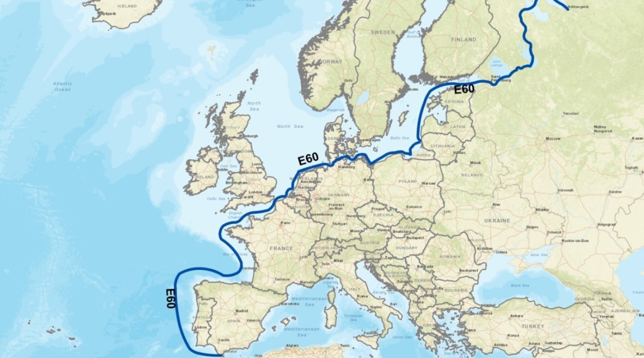

Scope of service
This order concerns the performance of a service consisting of a non-commercial pilot trip using a sea-river barge on the Vordingborg – Władysławowo – Kłaipeda route, together with the development of audiovisual documentation based on the following specifications. The pilot trip aims to demonstrate the possibility of using local seaports to handle cargo generated in the Baltic Sea Region. As a result, it is planned to develop regular shipping connections between local ports, increase their economic importance, develop regions located in the area of gravity of the international waterway E 60 and transfer part of the cargo from land roads to waterways.
The trip aims to establish cooperation between local ports and use their potential to develop short sea shipping. This will reduce CO² emissions and the negative impact of other external factors generated by transport, such as noise, congestion, costs of infrastructure degradation or accident costs.
The contractor will be responsible for providing an appropriate sea-river barge, which can handle bulk cargo and qualified personnel while maintaining the highest quality.
The sea-river barge will call at the ports listed above, according to the Ordering Party's schedule. In addition, a meeting/conference will be organised in each port, with the participation of interested entities, for which the Ordering Party will be responsible. At the same time, the Contractor will make a promotional film using a drone. The aim is to create a film that will promote the region, local seaports, short sea shipping, the INCONE60 project and the South Baltic programme 2014-2020.
Bearing in mind that the trip is promotional, the sea-river barge will be marked with banners with logos of the project, program and others provided by the Ordering Party.

Terms of service
- Requirements for a ship operating a pilot voyage:
- The contractor must provide a ship whose parameters will guarantee safe and trouble-free calling at the seaports: Vordingborg, Władysławowo and Klaipeda.
- Considering the characteristics of the INCONE60 project and the local seaports located in the Baltic Sea Region, the vessel should be adapted to handle bulk cargo.
- The ship should have a deadweight capacity of 1400 – 2000 DWT. Due to restrictions caused by the condition of the port infrastructure,
- The ship should meet certain requirements as to its parameters: maximum length 80m, maximum draught 3.6m.
- The vessel should comply with ISO 9001 2015.
- The ship must be marked with banners of the INCONE60 project, the South Baltic Programme and others provided by the Ordering Party.
- The order of port calls cannot be changed.
- Requirements for audiovisual documentation The Contractor, as part of this contract, is obliged to prepare audiovisual documentation in accordance with the following guidelines:
- Audiovisual documentation must be made using a drone,
- Captures must include port calls, port departures,
- The film should also include recordings of possible additional activities carried out during the pilot trip, e.g. demonstration transhipments in ports, which will be aimed at presenting the technical capabilities of local ports to handle cargo generated along the international waterway E60,
- The film must also include scenes from meetings in ports.
- The film must be made with a soundtrack, which will be agreed upon with the Ordering Party,
- The film must include logos of the INCONE60 project, the South Baltic Programme, the Maritime Institute, the Maritime University of Gdynia, the European Regional Development Fund and other additional ones. The Ordering Party will provide all graphic materials.
- The video must be made in 4K resolution.
- Shots of the film must be made to depict local seaports favourably.
- The film will be handed over to the Ordering Party by making it available in the cloud or on a digital medium after its acceptance and taking into account the Comments of the Ordering Party.

Deadline for the service
The service will be performed on May 10-12, 2022. Due to the interdependence of travel with port conferences, this date cannot be changed.

European Agreement on Main Inland Waterways of International Importance (AGN), Economic Commission for Europe Inland Transport Committe, Geneva 1996

